**ANEXA 3**



**LF155/LF156/LF256/LF257/LF355/LF356/LF357** **JFET Input Operational Amplifiers**

**General Description**

These are the first monolithic JFET input operational ampli- fiers to incorporate well matched, high voltage JFETs on the same chip with standard bipolar transistors (BI-FET™ Tech- nology). These amplifiers feature low input bias and offset currents/low offset voltage and offset voltage drift, coupled with offset adjust which does not degrade drift or common-mode rejection. The devices are also designed for high slew rate, wide bandwidth, extremely fast settling time, low voltage and current noise and a low 1/f noise corner.

n Logarithmic amplifiers

n Photocell amplifiers   
n Sample and Hold circuits   
**Common Features**   
n Low input bias current: 30pA   
n Low Input Offset Current: 3pA   
n High input impedance: 1012Ω   
n Low input noise current:   
n High common-mode rejection ratio: 100 dB   
n Large dc voltage gain: 106 dB

**Features**

**Advantages**

**Uncommon Features**

**LF155/**   
**LF355**

n Replace expensive hybrid and module FET op amps   
n Rugged JFETs allow blow-out free handling compared

**LF156/**   
**LF256/**   
**LF356**

with MOSFET input devices   
n Excellent for low noise applications using either high or

4 1.5 1.5 µs

low source impedance—very low 1/f corner   
n Offset adjust does not degrade drift or common-mode

j Extremely

fast settling   
time to   
0.01%

rejection as in most monolithic amplifiers   
n New output stage allows use of large capacitive loads

(5,000 pF) without stability problems   
n Internal compensation and large differential input voltage

j Fast slew

rate

5 12 50 V/µs

capability

2.5 5 20 MHz

**Applications**

j Wide gain

bandwidth

20 12 12

n Precision high speed integrators   
n Fast D/A and A/D converters   
n High impedance buffers   
n Wideband, low noise, low drift amplifiers

j Low input

noise   
voltage

**Simplified Schematic**

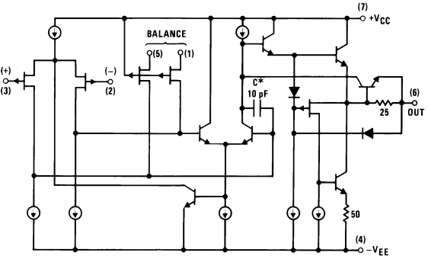

00564601

*3pF in LF357 series.

**LF257/** **LF357**

**(AV=5)**

**Units**



**LF155/LF156/LF256/LF257/LF355/LF356/LF357 JFET Input Operational Amplifiers**